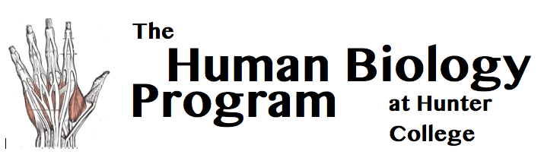 | Room 757 Hunter North 695 Park Avenue, NY, NY 10065 212.772.5418 humbio@hunter.cuny.edu
Independent Study (HMBIO402)
Bring this completed form to the Hum Bio Office hours
before the beginning of the semester that you would like to enroll.

Student Name: Email: Date:

Schedule: Start Date: End Date: Hours/Week: Total Hours:

Semester: Year: Credits (1-3): (″40h=1 Cr., ″  ″120h=3 Cr.)

To Be Filled out by FACULTY MEMBER

Faculty Name: Department: Email:

Please supply a brief description of the student’s independent study. (You may use this form or send an email to humbio@hunter.cuny.edu).

The hourly schedule provided above is accurate. I agree to send a brief evaluation of the student’s work by Dec 10th (Fall Sem.) or May 10th (Spring Sem.).

Faculty Signature: . Date :

To Be Filled out by STUDENT

I agree to send a 1-3 page paper (one page per credit) describing the independent study and its relationship to the Human Biology major by Dec 10th (Fall Semester) or May 10th (Spring Semester). I understand that without this paper and without the faculty’s end of semester evaluation, I will be given an INC grade.

Student Signature: . Date :

Hum Bio Advisor Name:

Hum Bio Advisor Signature:

Date:

Program Stamp:

