Page
Office of the Hunter College Senate
Room 1018 East Building Phone: 772-4200

DRAFT MINUTES
Meeting of the Hunter College Senate
27 October 2021

The 657th meeting of the Hunter College Senate convened at 3:38 PM via Zoom.

Presiding: Laura S. Keating, Chair

Attendance: The elected members of the Senate with the exception of those marked absent in Appendix I.

Alternate Senators were formally seated consistent with the procedures approved by the Senate for in-person meetings, and they were enabled to vote using iClicker.

Agenda The revised agenda was adopted with the provision to add two items to the Administrative Committee Report: an announcement and request to change the date of the 24 November meeting.

Minutes: The minutes of 4 November 2020, 18 November 2020, 2 December 2020 were approved as distributed.
The minutes of 9 December 2020, 10 February 2021, 24 February 2021 and 10 March 2021 were distributed by email and will be voted on at the next meeting.

Report by the
President President Raab’s report is in the Appendix II.

Report by the
Administrative
Committee: a) Approved Curriculum Changes
The following curriculum changes as listed in the attached reports Part II and Part II dated 27 October 2021 has been approved as per Senate resolution and are submitted for the Senate’s information. Items: US-2432 Dance (Change in course), GS-1386 Sociology (Change in course), US-2433 Jewish Studies Program (Change in courses), US-2434 Romance Languages/Italian (Change in degree program), US-2435 Music (Change in degree program), US-2436 Music (Change in degree program), US-2437 AFPRL (Change in Department Name), US-2438 Political Science (New course and Add “W” designation), GS-1387 Romance Languages/Italian (New course), and GS-1388 Special Education (New degree program).

b) Reminder: Nominations for Search Committee for Vice President for Finance, Human Resources, and Business Development
Chair Keating announced that the deadline for nominations has been extended to Thursday, 4 November.

c) Reminder: Complete survey
Chair Keating announced that the deadline for departments and programs to submit their responses to the Qualtrix survey sent out on 4 October has been extended to Monday, 15 November. This survey was mandated by a resolution passed by the Senate on 10 March, 2021.

d) Request to Change Senate Meeting Date
The Administrative Committee requested permission to move the 24 November meeting to either Wednesday, 17 November or 1 December, as needed. The date would be announced after the 10 November meeting.
The motion carried by unanimous consent.

Committee
Report Nominating Committee
Chair Keating called on Professor Lisa Marie Anderson, Chair of the Nominating Committee, to present a report.

The Nominating Committee is submitting the following nominations for seats currently vacant on Senate Committees:

- GRADUATE COURSE OF STUDY & ACADEMIC REQUIREMENTS COMMITTEE
Faculty Alternate: April Kisamore (Special Education)

- COMMITTEE ON THE LIBRARY
Faculty from Social Work: Marina Lalayants

- COMMITTEE ON THE EVALUATION OF TEACHING
Faculty: Kathryn Furlong (Special Education)

It was moved that the Secretary be instructed to cast a single ballot in favor of the nominees.
The motion carried by unanimous consent.

Committee on General Education and Committee on Academic Assessment & Evaluation
Chair Keating called on Professor Lawrence Kowerski, Chair of the General Education Committee, and Professor Gina Riley, Chair of the Academic Assessment and Evaluation Committee, to present a joint report (see Appendix III for the PowerPoint presentation). The report is available at the Senate Office.

Committee of
the Whole On Moving Forward from the Pandemic – Modes of Instruction
Chair Keating began by inviting Professor Jeanne Weiler, co-Chair of the Undergraduate Course of Study Committee, to report. The report is in Appendix IV.

After Professor Weiler’s report, it was moved that the Senate dissolve itself into a quasi-Committee of the Whole to discuss a draft resolution that had been circulated earlier that afternoon (see Appendix V) until 5:25 PM, and that Professor Laura Keating, Chair of the Senate, chair the committee.

The motion carried by unanimous consent.

At 5:28 PM the Senate reconvened into formal session.

Due to the late hour, the meeting was adjourned at 5:28 PM.

Respectfully submitted,

Sarah Jeninsky
Secretary

Minutes Page
Meeting of the Hunter College Senate
27 October 2021

APPENDIX I
The following attendance was noted from the meeting (A) =Alternate, A=Attended, X=Absent, E=Excused

Minutes Page
Meeting of the Hunter College Senate
27 October 2021

APPENDIX II

Minutes Page
Meeting of the Hunter College Senate
27 October 2021

APPENDIX III

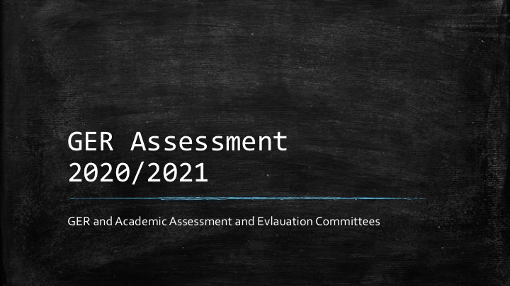

Minutes Page
Meeting of the Hunter College Senate
27 October 2021

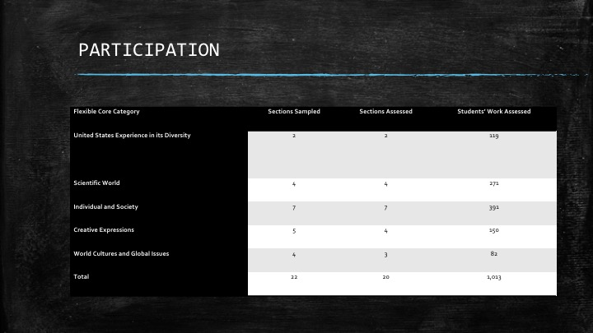

Minutes Page
Meeting of the Hunter College Senate
27 October 2021

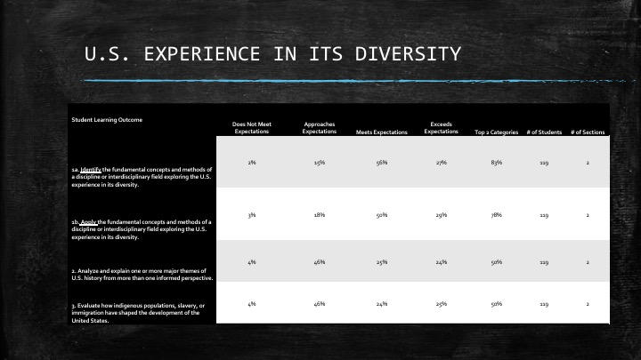

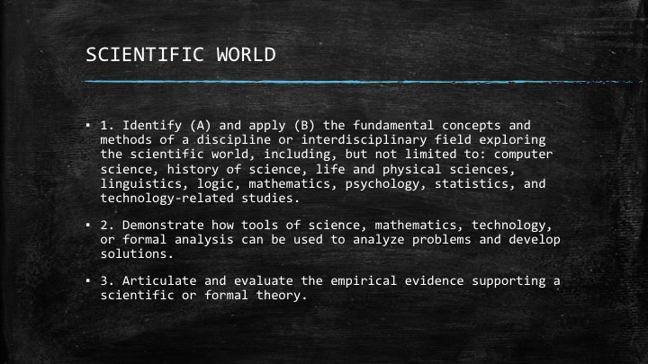

Minutes Page
Meeting of the Hunter College Senate
27 October 2021

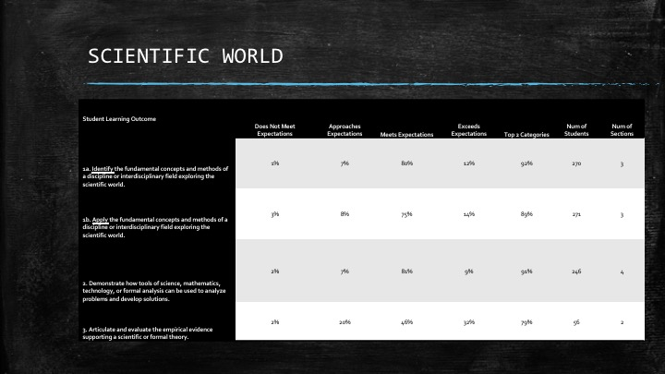

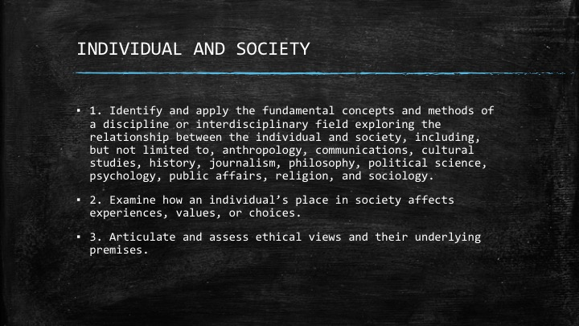

Minutes Page
Meeting of the Hunter College Senate
27 October 2021

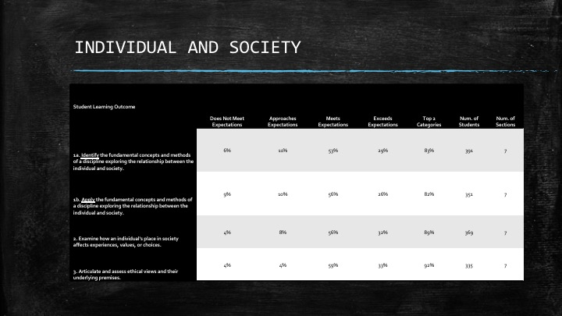

Minutes Page
Meeting of the Hunter College Senate
27 October 2021

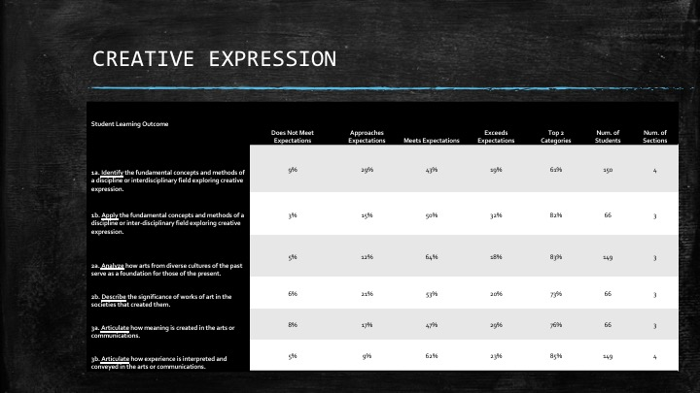

Minutes Page
Meeting of the Hunter College Senate
27 October 2021

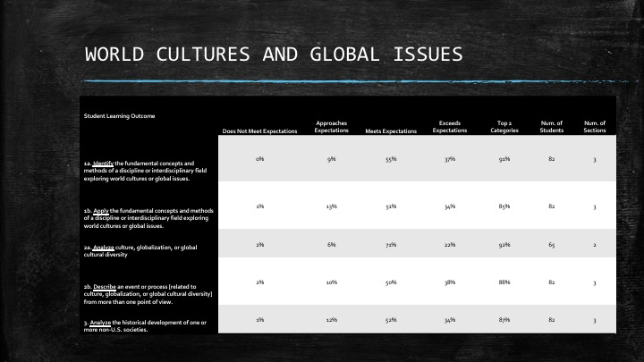

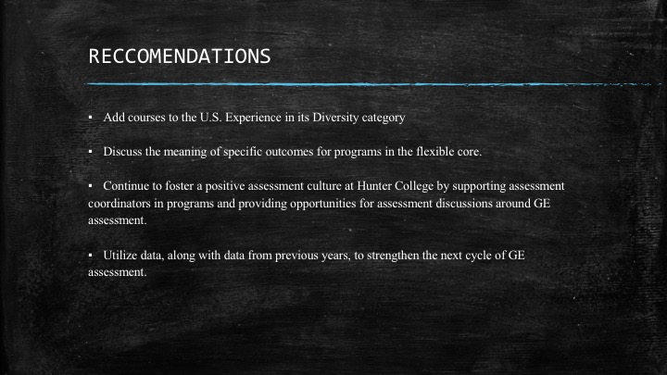

Minutes Page
Meeting of the Hunter College Senate
27 October 2021

APPENDIX IV

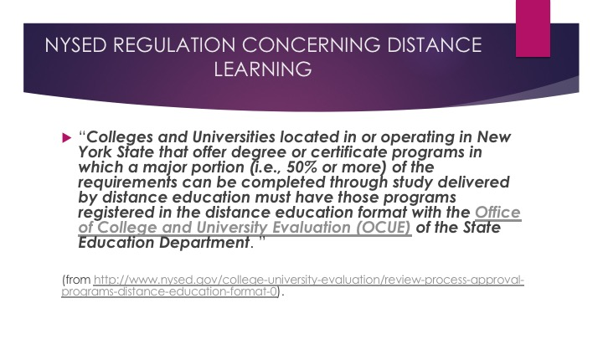
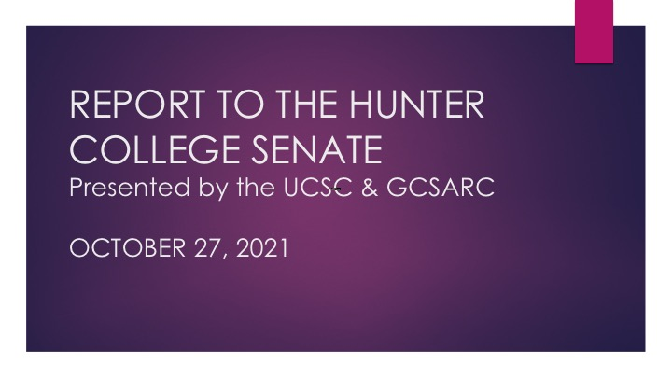

Minutes Page
Meeting of the Hunter College Senate
27 October 2021

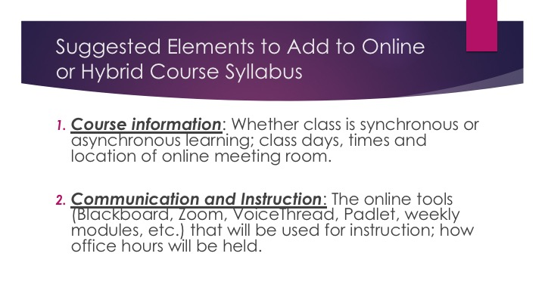

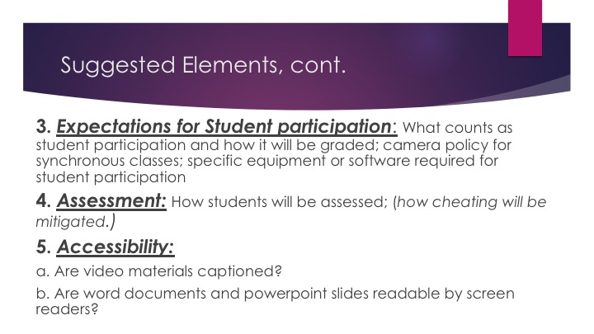

Minutes Page
Meeting of the Hunter College Senate
27 October 2021

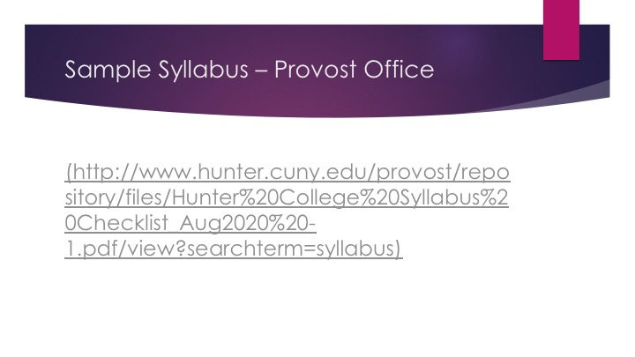

Minutes Page
Meeting of the Hunter College Senate
27 October 2021

APPENDIX V

On Moving Forward on Modes of Instruction from the Pandemic Emergency- Draft Oct 21

Whereas, The Senate and the Senate Administrative Committee (SAC) has been gratified by the successful partnership with the Hunter and CUNY administrations in dealing with the uncertainties of the Covid virus and how it affects pedagogy, students, faculty, staff, and the broader Hunter College community;

Whereas, We have embraced the need for extraordinary measures and have temporarily ceded some Senate and faculty prerogatives to enable the Hunter College community to responsively address issues and needs as they have arisen in this period;

Whereas, One of the temporarily ceded prerogatives concerns the mode of delivery of instruction;

Whereas, This semester we have already started the move towards non-emergency operation and expect that to continue in subsequent semesters;

Whereas, Two anticipated changes are that
a) new course proposals may involve a course having more than one mode of instruction (or instructional modality), where if approved, that course could be taught in any of those modes in any semester (at the discretion of the department/program),
b) some departments/programs may want to start regularly offering online sections of courses that were originally conceived, approved, and offered under the in-person modality;

Whereas, The policy of the Senate in the past has been “that the responsibility for ensuring the content, curriculum, pedagogy, assessment, format, and delivery of all instruction rests with academic departments or equivalent units of the College. All changes in any of the above-mentioned areas must, as a rule, be approved by a departmental curriculum committee or equivalent body. If such changes are substantive, a curriculum proposal going through the established approval process is required” (Minutes of 4-21-2010, p.5413);

Whereas, In recent years and months the variety of modes of instruction in college instruction has greatly expanded and is still in the process of being developed and distinguished, and for some modes, adding a mode of instruction to a course is substantive and may affect the nature of a program; and

Whereas, The Senate curriculum committees are currently deliberating on their processes for adding modes of instruction to existing courses on the books and for approving new courses for more than one mode of instruction;

Resolved, That the Senate exercise its policy making responsibility on instruction starting this semester by allowing, while Senate processes are being developed, departments to maintain discretion, consistent with rules of NYSED and the decisions of CUNY and the BOT, on the modes of instruction utilized in its semesterly offerings for courses already on the books. After a year in which a Senate process is in place, departments and programs may only utilize a modality that has been approved by the relevant Senate curriculum committee for that course.

